American International University-Bangladesh-(AIUB)
Programming in Python
Final-Term Project
Summer 2025-26 Semester
Project Title:
TELCO CUSTOMER CHURN PREDICTION
USING MACHINE LEARNING

Submitted To:
MD. KAMRUL ISLAM

Submitted By:

Name | ID
Mahabub Islam | 23-50725-1
Kazi Umma Jannat | 23-50465-1

Group No: 02

1. Project Title
Project Title: Telco Customer Churn Prediction Using Machine Learning
This project develops a machine-learning classification workflow to predict whether a telecommunications customer is likely to churn using demographic, service, contract, tenure, payment, and billing information.

2. Problem Statement, Stakeholders, Objective and Success Criteria
Customer churn is an important concern for telecommunications companies because losing existing customers can reduce revenue and increase customer-acquisition costs. The project treats churn as a binary classification problem, where Churn = Yes indicates that a customer left the service and Churn = No indicates that the customer remained.
The main stakeholders are telecommunications service providers, customer-retention teams, marketing teams, and business analysts. The objective is to build a reproducible, leakage-safe workflow that audits the data, compares a baseline with multiple classifiers, tunes models using training-data cross-validation, and evaluates the selected model once on an untouched test set.
Because the churn class is imbalanced, success is assessed using precision, recall, F1-score, ROC-AUC, PR-AUC, and the confusion matrix rather than accuracy alone.

3. Dataset Source, Data Dictionary, Privacy and Ethics
The supplied dataset contains 7,043 customer records and 21 original columns. The target variable is Churn. There are 5,174 non-churn customers (73.46%) and 1,869 churn customers (26.54%). IBM identifies Telco customer churn as sample data from a fictional telecommunications company and lists customer characteristics such as gender, dependents, monthly charges, and service information.
Dataset access used by the group: https://www.kaggle.com/datasets/palashfendarkar/wa-fnusec-telcocustomerchurn
The exact standalone license for the specific CSV supplied for this project was not documented in the available project materials; therefore, this report does not assign an unverified license. IBM is acknowledged as the original sample-data source, and the dataset is used here for academic coursework.
Variable | Type | Description
customerID | Identifier | Unique customer identifier; excluded from modelling
gender | Categorical | Customer gender
SeniorCitizen | Binary numeric | Senior-citizen indicator (1/0)
Partner | Categorical | Whether customer has a partner
Dependents | Categorical | Whether customer has dependents
tenure | Numeric | Months with the company
PhoneService | Categorical | Phone service status
MultipleLines | Categorical | Multiple-lines status
InternetService | Categorical | Internet service type
OnlineSecurity | Categorical | Online-security status
OnlineBackup | Categorical | Online-backup status
DeviceProtection | Categorical | Device-protection status
TechSupport | Categorical | Technical-support status
StreamingTV | Categorical | Streaming TV status
StreamingMovies | Categorical | Streaming-movies status
Contract | Categorical | Contract type
PaperlessBilling | Categorical | Paperless-billing status
PaymentMethod | Categorical | Payment method
MonthlyCharges | Numeric | Monthly charge
TotalCharges | Numeric | Total accumulated charge
Churn | Binary target | Yes = churn; No = non-churn

Privacy and ethics: customerID is excluded from prediction because it is an identifier. Demographic variables may raise fairness concerns in real deployment. Model outputs represent predictive associations, not causal effects, and should support rather than automatically determine customer treatment.

4. Data Audit, Exploratory Analysis and Visualization Findings
The data audit found 0 duplicate rows and 0 duplicate customer IDs. The main data-quality issue was 11 blank entries in TotalCharges. These entries were converted to missing numeric values and later imputed inside the training pipeline rather than being manually filled before the train-test split.

Churn Status | Frequency | Percentage
No | 5,174 | 73.46%
Yes | 1,869 | 26.54%

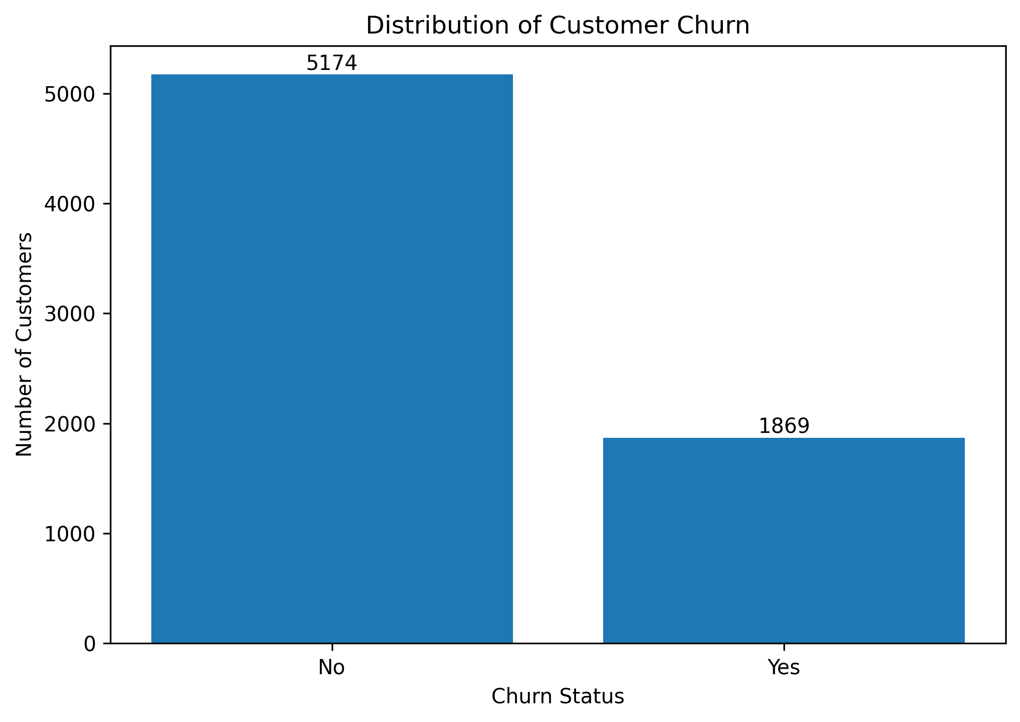
Figure 1. Distribution of customer churn.
Contract type showed a clear descriptive relationship with churn: month-to-month customers had a churn rate of 42.71%, compared with 11.27% for one-year contracts and 2.83% for two-year contracts. Churn customers also had shorter tenure on average (17.98 months) than non-churn customers (37.57 months), while their average MonthlyCharges were higher (74.44 versus 61.27). These are associations and are not interpreted as causal effects.

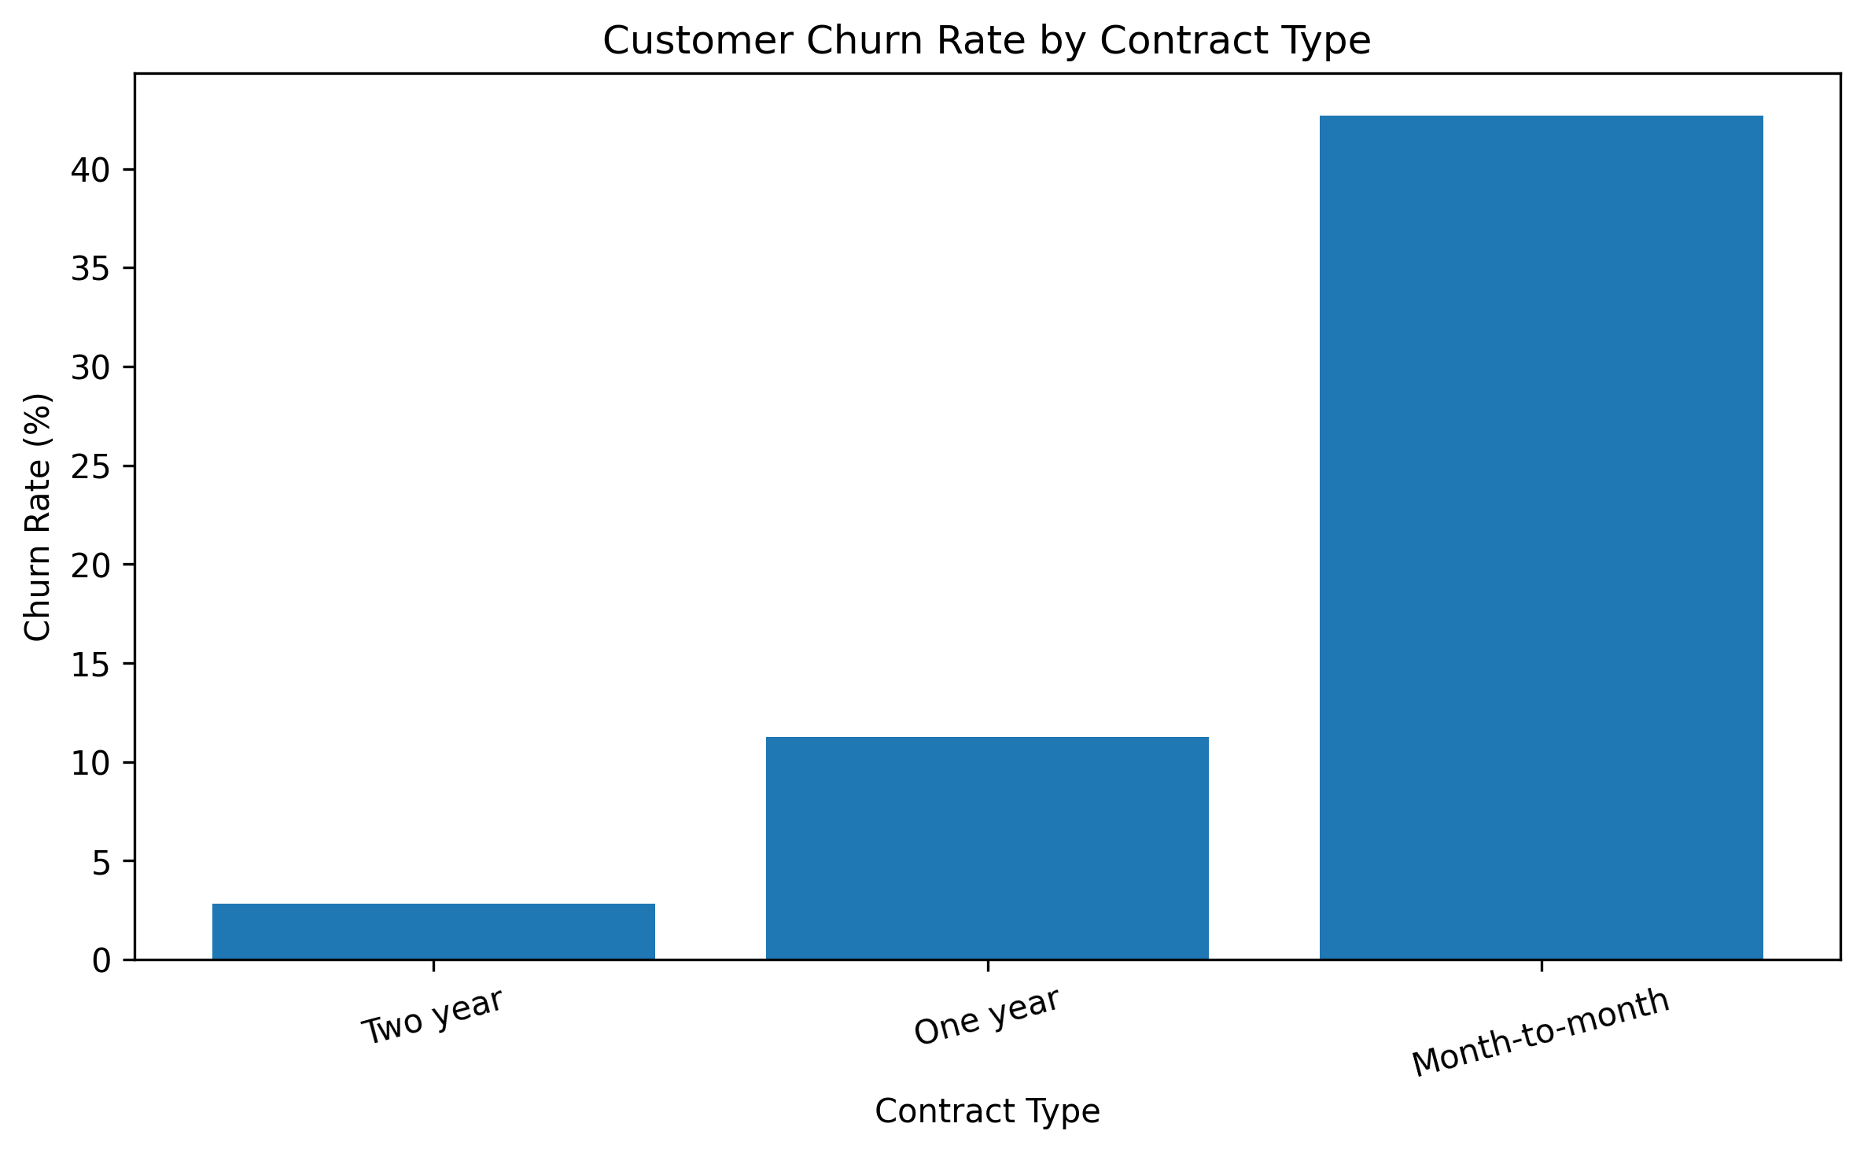
Figure 2. Churn rate by contract type.

5. Split Strategy, Preprocessing and Leakage Control
The data were divided into an 80% training set (5,634 records) and a 20% test set (1,409 records) using stratification on Churn and random_state = 42. The split was completed before fitting data-dependent preprocessing. The test set remained untouched during preprocessing, hyperparameter tuning, and model selection.

Feature Type | Preprocessing
Numerical | Median imputation -> StandardScaler
Categorical | Most-frequent imputation -> OneHotEncoder(handle_unknown="ignore")

Numerical and categorical transformations were combined with ColumnTransformer and included inside Scikit-learn Pipelines. Consequently, the median used for missing TotalCharges values, scaling statistics, and encoding rules were learned from training data only. Class imbalance was addressed using stratification, multiple evaluation metrics, and tunable class weighting; no SMOTE or synthetic oversampling was used.

6. Baseline Model and Result
A Dummy Classifier using the most-frequent-class strategy was used as the baseline. It achieved 0.7346 cross-validation accuracy but zero precision, recall, and F1 for the churn class, with ROC-AUC = 0.5000. This showed that a high accuracy value could be obtained by predicting the majority non-churn class while identifying no churn customers.

Metric | Dummy Classifier
CV Accuracy | 0.7346
CV Precision | 0.0000
CV Recall | 0.0000
CV F1-score | 0.0000
CV ROC-AUC | 0.5000

7. Candidate Models, Hyperparameters and Validation
Logistic Regression, K-Nearest Neighbours (KNN), and Random Forest were compared using the same training split and pipeline logic. Logistic Regression provided an interpretable linear benchmark, KNN provided a distance-based alternative requiring scaling, and Random Forest provided a nonlinear tabular model that can capture interactions and support class weighting. Hyperparameters were selected with GridSearchCV using 5-fold Stratified Cross-Validation. F1-score was predefined as the primary refitting and model-selection metric because both precision and recall matter for the minority churn class.

Model | Accuracy | Precision | Recall | F1 | ROC-AUC
Dummy Classifier | 0.7346 | 0.0000 | 0.0000 | 0.0000 | 0.5000
Random Forest | 0.7767 | 0.5613 | 0.7298 | 0.6342 | 0.8439
Logistic Regression | 0.7508 | 0.5199 | 0.7980 | 0.6295 | 0.8455
KNN | 0.7906 | 0.6111 | 0.5799 | 0.5950 | 0.8284

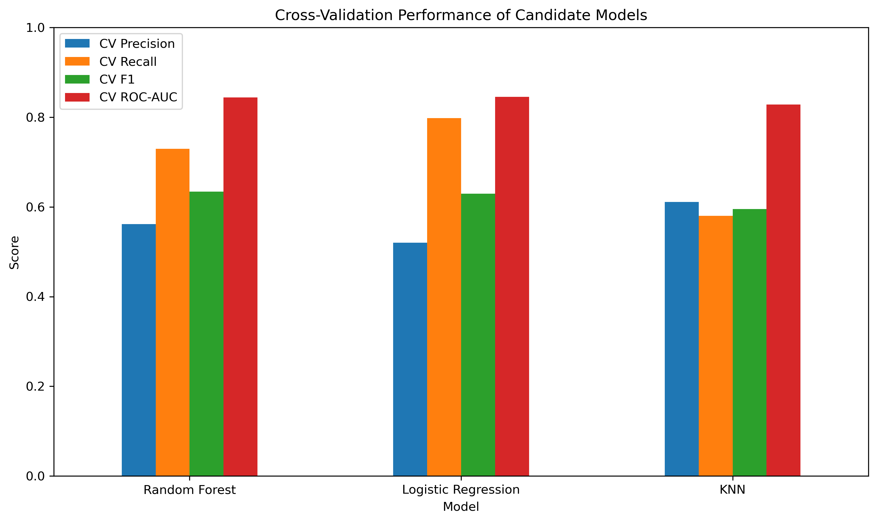
Figure 3. Cross-validation comparison of candidate models.
Random Forest achieved the highest mean cross-validation F1-score (0.6342), narrowly exceeding Logistic Regression (0.6295). Because the difference was only 0.0047, Random Forest is not described as substantially superior; it was selected because it ranked first under the predefined F1-based rule.

Random Forest Parameter | Selected Value
n_estimators | 100
max_depth | 10
min_samples_leaf | 3
class_weight | balanced
random_state | 42
n_jobs | -1

8. Final Evaluation and Model Performance
After model selection was completed on the training data, the selected Random Forest was evaluated once on the untouched 1,409-record test set.

Metric | Final Test Result
Accuracy | 0.7637
Precision | 0.5406
Recall | 0.7299
F1-score | 0.6212
ROC-AUC | 0.8388
PR-AUC | 0.6431

The model correctly identified 273 of 374 actual churn customers, producing recall = 0.7299. Its ROC-AUC of 0.8388 indicates useful discrimination across thresholds. Test F1 (0.6212) and test ROC-AUC (0.8388) were reasonably close to the corresponding cross-validation values of 0.6342 and 0.8439. Class-wise test performance is shown below.

Class | Precision | Recall | F1-score | Support
No Churn | 0.8883 | 0.7758 | 0.8283 | 1035
Churn | 0.5406 | 0.7299 | 0.6212 | 374

The model performed better for the non-churn class, while the churn class had lower precision but relatively strong recall. This means the model identified a substantial proportion of actual churn customers, although some non-churn customers were incorrectly flagged as churn.

Actual / Predicted | Predicted Non-Churn | Predicted Churn
Actual Non-Churn | 803 | 232
Actual Churn | 101 | 273

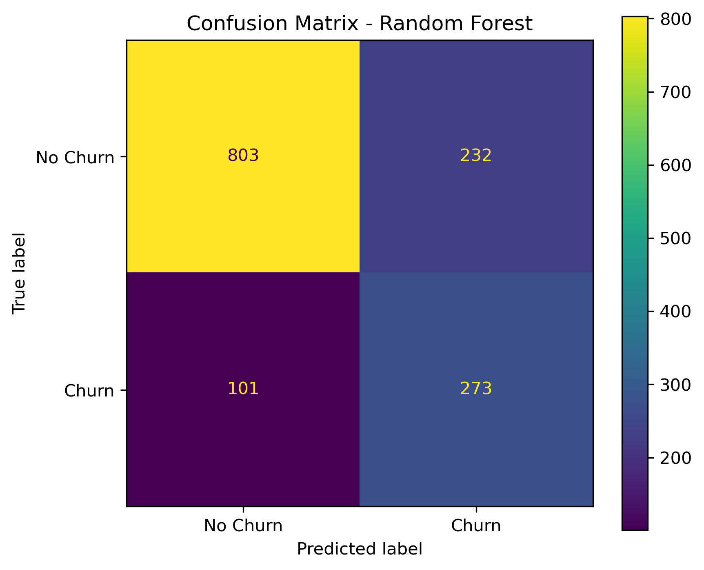
Figure 4. Confusion matrix for the final Random Forest model.
Computational cost was documented programmatically in the notebook. Training time was 8.4706 seconds for Random Forest, 1.4503 seconds for Logistic Regression, and 1.6542 seconds for KNN. The selected Random Forest used 100 trees, a maximum depth of 10, and n_jobs = -1 for parallel execution. Final Random Forest inference on the 1,409-record test set took 0.0388 seconds. Random Forest therefore required more training time than the other candidate models, while final inference remained fast.

9. Error Analysis, Bias and Limitations
The final model produced 232 false positives and 101 false negatives. False positives could lead to unnecessary retention interventions, while false negatives represent churn customers the company may fail to identify. The default classification threshold was retained; no threshold was optimized on the final test set.
Grouped Random Forest feature importance showed that Contract was the most influential original feature, followed by tenure, TotalCharges, OnlineSecurity, InternetService, MonthlyCharges, TechSupport, and PaymentMethod. Feature importance measures predictive contribution only; it does not establish direction or causality.

Feature | Importance
Contract | 0.1941
tenure | 0.1185
TotalCharges | 0.1024
OnlineSecurity | 0.0888
InternetService | 0.0737
MonthlyCharges | 0.0721
TechSupport | 0.0705
PaymentMethod | 0.0653

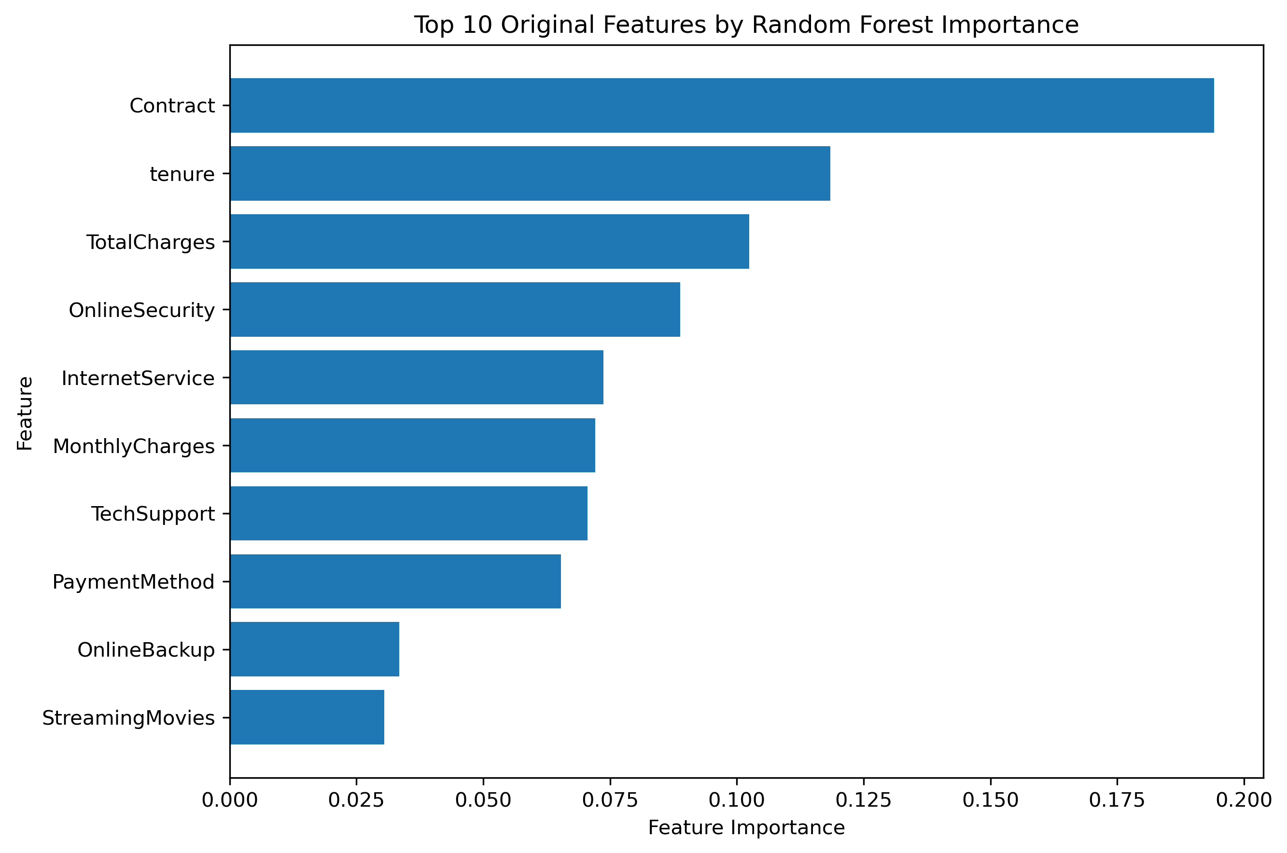
Figure 5. Top grouped Random Forest feature importances.
- The dataset represents an IBM fictional/sample telecommunications setting and may not generalize to other companies or future periods.
- Potentially relevant variables such as customer satisfaction, complaint history, service outages, and competitor offers are absent.
- Demographic variables may create fairness concerns; subgroup performance was not fully assessed.
- Customer behaviour can change over time, creating distribution-shift risk.
- A small CV F1 difference (0.0047) separates Random Forest and Logistic Regression, so superiority should not be overstated.

10. Reproducibility Information
The analysis was implemented in a Jupyter Notebook using relative project paths, random_state = 42, an 80/20 stratified train-test split, 5-fold Stratified Cross-Validation, and pipeline-based preprocessing. The completed notebook was successfully restarted and executed from beginning to end, producing the confirmation message: PROJECT FINALIZATION CHECK COMPLETED.
Environment versions: Python 3.13.5; NumPy 2.1.3; Pandas 2.2.3; Scikit-learn 1.6.1. Random state = 42, test size = 20%, and cross-validation = 5-fold Stratified Cross-Validation. To reproduce the analysis, install the required packages with pip install -r requirements.txt, open notebooks/Telco_Customer_Churn_Prediction.ipynb, restart the kernel, and run all cells from top to bottom. The notebook regenerates the final figures and result files using relative project paths.
Final project structure:
Telco_Customer_Churn_Project/
├── data/
│ └── WA_Fn-UseC_-Telco-Customer-Churn.csv
├── notebooks/
│ └── Telco_Customer_Churn_Prediction.ipynb
├── figures/
│ └── generated figures
├── results/
│ └── generated metrics, error records and final model
├── README.md

11. Conclusion and Future Improvements
This project developed a reproducible, leakage-safe machine-learning workflow for telecommunications churn prediction. Random Forest was selected because it achieved the highest cross-validation F1-score (0.6342). On the untouched test set it achieved accuracy = 0.7637, precision = 0.5406, recall = 0.7299, F1 = 0.6212, ROC-AUC = 0.8388, and PR-AUC = 0.6431.
The results show that customer contract structure, tenure, billing information, and service characteristics contain useful predictive information. However, the model makes both false-positive and false-negative errors and should be used as a decision-support tool rather than an automatic decision-making system.
Future work could include subgroup fairness analysis, validation-based threshold selection using explicit business costs, probability calibration, repeated cross-validation, additional justified models, and evaluation using current real-world telecommunications data.

12. References and Contribution Statement
IBM Samples Team. (2018). New Base Samples for IBM Cognos Analytics 11.1.1: Telco customer churn sample data. IBM Community.
IBM. (2020). Cognos Analytics Samples Guide: Telco churn relationships exploration sample.
Pedregosa, F., Varoquaux, G., Gramfort, A., Michel, V., Thirion, B., Grisel, O., et al. (2011). Scikit-learn: Machine Learning in Python. Journal of Machine Learning Research, 12, 2825-2830.
Programming in Python. (2026). Python Final-Term Project Requirements: Summer 2025-26 Semester. Course project document.
Source URLs:
- IBM sample description: https://community.ibm.com/community/user/blogs/steven-macko/2018/11/26/new-base-samples-for-ibm-cognos-analytics-1111
- JMLR scikit-learn paper: https://www.jmlr.org/papers/v12/pedregosa11a.html

Contribution Statement (Two Members)
Member | Student ID | Actual Contribution
Mahabub Islam | 23-50725-1 | Data preprocessing, exploratory data analysis, visualization, model implementation, and evaluation.
Kazi Umma Jannat | 23-50465-1 | Dataset documentation, result interpretation, report preparation, reproducibility checking

AI-Assisted Work Disclosure
Generative AI was used as a supporting tool for explaining concepts, organizing the workflow, reviewing code structure, and assisting with report drafting. The project code was executed and tested by the group, and the numerical results reported here were generated from the submitted Jupyter Notebook. All final content should be reviewed by both group members before submission.

